General Properties of Enzymes
i. Enzymes possess enormous catalytic power. Most accelerate reactions by factors of at least 1 million.
Consider the reaction catalysed by carbonic anhydrase
CO₂ + H₂O ↔ H₂CO₃
The enzyme is responsible for effecting the transfer of CO₂ from the tissues into the blood and then to the alveoli. Each enzyme is capable of hydrating 10⁵ molecules of CO₂ in one second. The catalysed reaction is 10⁷ times faster than the uncatalysed reaction.

ii. They are highly specific both the reaction catalysed and their choice of reactants.
Four distinct types of enzyme specificity have been identified. They include
A. Absolute specificity, where the enzyme catalyses only one reaction.
B. Group specificity. The enzyme acts only on molecules with specific functional groups.
C. Linkage specificity- The enzyme acts on a particular type of chemical bond regardless of the rest of the molecular structure.
E.g. Trypsin splits peptide bonds on the carboxyl side of lysine and arginine residues only while thrombin acts only when the side chain on the carboxyl side is arginine while the one on the amino side is glycine.
D. Stereochemical specificity. The enzyme acts on a particular steric or optical Isomer.

iii. They do not alter reaction equilibria
The combination of substrate and enzyme creates a new reaction pathway whose transition state energy is lower than it would be if the reaction were taking place in the absence of an enzyme. However, in this process, both the forward and reverse reactions are accelerated by precisely the same factor. Thus enzymes accelerate the attainment of equilibria but do not shift their position.
The enzyme stabilises the transition state, reducing the energy needed to form products.

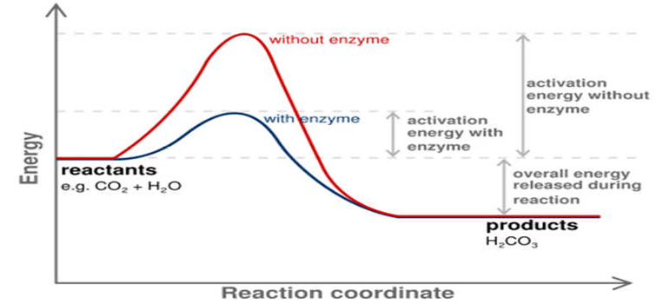
Figure: Enzymes do not Alter Reaction.

iv. Enzymes are stable over only a limited range of Temperature
Generally, a higher temperature brings about an increase in the movement of enzyme and substrate molecules, resulting in more collisions between the molecules and formation of more products. (a 10ºC rise in temperature increases the activation energy of the molecules by about 12 Kcal/Mol). However, if the temperature rises beyond a certain point (which differs for each enzyme), the enzyme activity levels out and then declines rapidly.
This is because the enzyme is denatured by heat. The tertiary structure of the enzyme is altered and it can no longer function.
Human enzymes generally exhibit stability at temperatures up to 45 - 55ºC. Thermophilic enzymes may be stable up to or above 100ºC. For mammals and other homoeothermic organisms, changes in enzyme reaction rates with temperature assume physiologic importance only in circumstances such as fever or hypothermia.
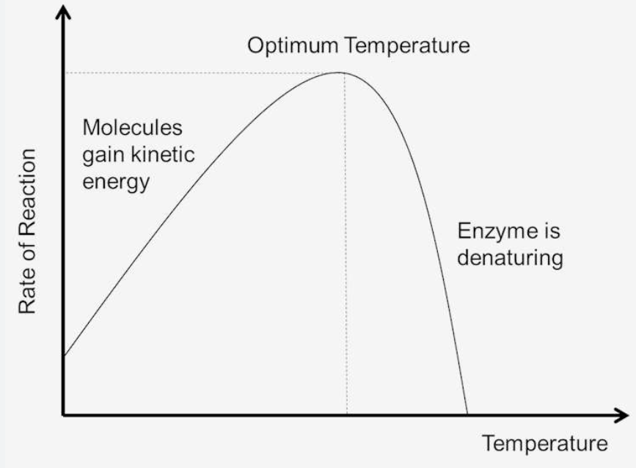
Figure: Effect of Temperature on Reaction Rate
v. Enzymes are stable over only a limited range of pH. Each enzyme has an optimal pH range that help maintain its normal configuration in the environment where it operates. Outside this range, changes in the charges on ionizable amino acid residues result in modification of the tertiary structure of the protein and eventually lead to denaturation. Examples of pH optima include those of the digestive enzymes: Pepsin-2.0, Trypsin-10.0 and Chymotrypsin-8.0.

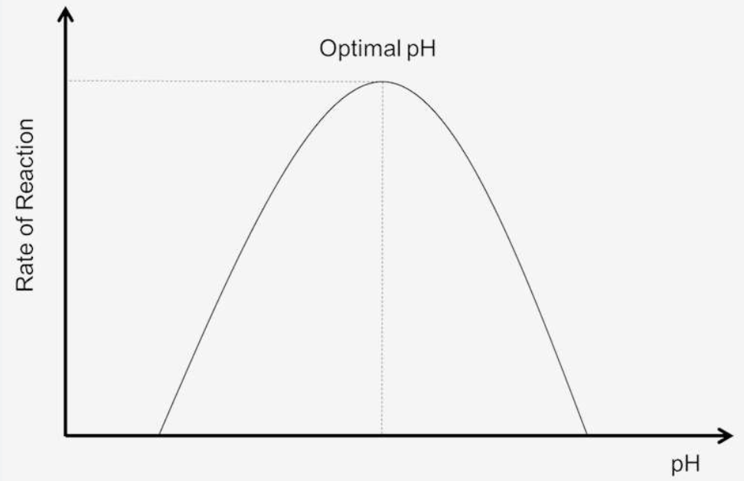
Figure: Effect of pH on Reaction Rate

vi. Enzymes are influenced by the concentration of substrate
At very low [S], collisions between enzyme and substrate are infrequent and the reaction proceeds slowly. As [S] increases, reaction rate increases proportionately as collisions become more frequent.
Rate α [A] [B]
When the enzyme begins to approach the maximum rate at which it can combine with substrate, the effect of increasing [S] diminish. At saturation point, the reaction is no longer affected by increase in [S].The rate of the reaction at this point is called maximum velocity. The [S] at which we have Vmax is called Km, (Michelis constant) for a particular enzyme.
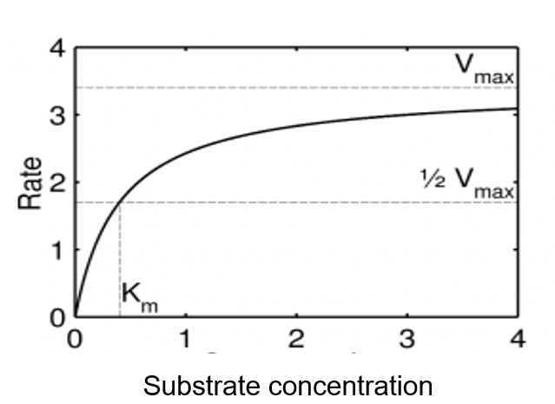
Figure: Saturation Curve for an Enzyme Reaction showing the Relation [S] and Rate (v).

